**From:** Nwaghodoh, Ginikanwa F SPDC-UPC/G/CP   
**Sent:** 22 August 2022 09:18  
**To:** Udo, Idongesit E SPDC-FUP/OGS <idongesit.udo@shell.com>  
**Cc:** Oso, Joseph N SNBO-FUP/CGC <Joseph.Oso@shell.com>  
**Subject:** RE: SPDC Receivable Report as at 31 July 2022

Ok, this is good news then.

That means they are up to date!

**From:** Udo, Idongesit E SPDC-FUP/OGS <[idongesit.udo@shell.com](mailto:idongesit.udo@shell.com)>   
**Sent:** 22 August 2022 08:05  
**To:** Nwaghodoh, Ginikanwa F SPDC-UPC/G/CP <[ginikanwa.nwaghodoh@shell.com](mailto:ginikanwa.nwaghodoh@shell.com)>  
**Cc:** Oso, Joseph N SNBO-FUP/CGC <[Joseph.Oso@shell.com](mailto:Joseph.Oso@shell.com)>  
**Subject:** RE: SPDC Receivable Report as at 31 July 2022

*Good morning Ginika,*

*USD97k is not an omission. Invoices fully settled as per analysis below:*

|  |  |  |  |  |  |  |  |  |
| --- | --- | --- | --- | --- | --- | --- | --- | --- |
| ***Account*** | ***Customer*** | ***DocumentNo*** | ***Text*** | ***Pstng Date*** | ***Curr.*** | ***Amount in DC*** | ***LCurr*** | ***Amt in loc.cur.*** |
|  |  |  | ***OUTSTANDING*** |  |  |  |  |  |
| *110260* | *NPDC/HERITAGE/SHORELINE OML 30* | *104116335* | *Payment on Account* | *08/11/21* | *NGN* | *(29,468,942.79)* | *USD* | *(71,942.53)* |
| *110260* | *NPDC/HERITAGE/SHORELINE OML 30* | *1800026781* | *NPDC/HERITAGE shared services Jun-Sept 2021-OML 30* | *10/27/21* | *NGN* | *31,698,089.36* | *USD* | *77,213.38* |
|  |  |  |  |  |  | ***2,229,146.57*** |  | ***5,270.85*** |
|  |  |  | ***PAYMENT*** |  |  |  |  |  |
| *110260* | *NPDC/HERITAGE/SHORELINE OML 30* | *1400016809* | *Elcrest OML30 Recovery Pmt* | *07/20/22* | *NGN* | ***-2,229,146.50*** |  | ***-5,292.22*** |
|  |  |  |  |  |  | ***0.07*** |  |  |
|  |  |  | ***OUTSTANDING*** |  |  |  |  |  |
| *110260* | *NPDC/HERITAGE/SHORELINE OML 30* | *1800027235* | *NPDC/HERITAGE shared services Oct-Dec 2021-OML 30* | *01/19/22* | *USD* | *25,650.80* | *USD* | *25,650.80* |
| *110260* | *NPDC/HERITAGE/SHORELINE OML 30* | *1800026299* | *NPDC/HERITAGE shared services Mar-May 2021-OML 30* | *07/12/21* | *USD* | *17,722.00* | *USD* | *17,722.00* |
| *110260* | *NPDC/HERITAGE/SHORELINE OML 30* | *1800026782* | *NPDC/HERITAGE shared services Jun-Sept 2021-OML 30* | *10/27/21* | *USD* | *35,553.20* | *USD* | *35,553.20* |
| *110260* | *NPDC/HERITAGE/SHORELINE OML 30* | *1800025377* | *NPDC/HERITAGE shared services Sept-Nov 2020-OML30* | *01/06/21* | *USD* | *6,692.56* | *USD* | *6,692.56* |
| *110260* | *NPDC/HERITAGE/SHORELINE OML 30* | *1800025785* | *NPDC/HERITAGE shared services-Dec 20-Feb 21-OML 30* | *03/26/21* | *USD* | *6,409.90* | *USD* | *6,409.90* |
|  |  |  |  |  |  | ***92,028.46*** |  | ***92,028.46*** |
|  |  |  |  |  |  |  |  |  |
|  |  |  | ***PAYMENT*** |  |  |  |  |  |
| *110260* | *NPDC/HERITAGE/SHORELINE OML 30* | *1400016813* | *Heritage Pmt_Recovery* | *07/22/2022* | *USD* | ***-92,028.46*** | *USD* | ***-92,028.46*** |
|  |  |  |  |  |  | ***-*** |  |  |

*Regards,*

*Idongesit*

**From:** Nwaghodoh, Ginikanwa F SPDC-UPC/G/CP <[ginikanwa.nwaghodoh@shell.com](mailto:ginikanwa.nwaghodoh@shell.com)>   
**Sent:** Sunday, August 21, 2022 10:39 AM  
**To:** Oso, Joseph N SNBO-FUP/CGC <[Joseph.Oso@shell.com](mailto:Joseph.Oso@shell.com)>  
**Cc:** Udo, Idongesit E SPDC-FUP/OGS <[idongesit.udo@shell.com](mailto:idongesit.udo@shell.com)>  
**Subject:** RE: SPDC Receivable Report as at 31 July 2022

Good morning Joseph

Congrats on the new role.

Pls can you help us review the report once again – I checked the July 2022 report but did not see the line below.

Pls can you help me cross check?

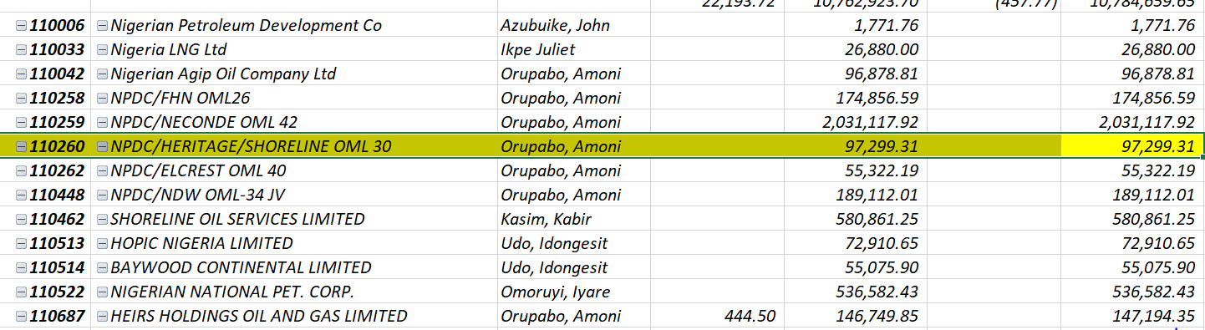

**From:** Oso, Joseph N SNBO-FUP/CGC <[Joseph.Oso@shell.com](mailto:Joseph.Oso@shell.com)>   
**Sent:** 04 August 2022 15:13  
**To:** Azubuike, John I SPDC-FUP/CGA <[John.Azubuike@shell.com](mailto:John.Azubuike@shell.com)>; Eneh, Pearl N SPDC-UPC/G/CP <[Pearl.Eneh@shell.com](mailto:Pearl.Eneh@shell.com)>; Nwaghodoh, Ginikanwa F SPDC-UPC/G/CP <[ginikanwa.nwaghodoh@shell.com](mailto:ginikanwa.nwaghodoh@shell.com)>; Ogbonna, Kingsley C SPDC-UPC/G/CP <[kingsley.ogbonna@shell.com](mailto:kingsley.ogbonna@shell.com)>; Usman, Mohammed S SPDC-UPC/G/CPG <[mohammed.usman@shell.com](mailto:mohammed.usman@shell.com)>  
**Cc:** Ige, Oludare A SNBO-FUP/CGC <[O.Ige7@shell.com](mailto:O.Ige7@shell.com)>; Udo, Idongesit E SPDC-FUP/OGS <[idongesit.udo@shell.com](mailto:idongesit.udo@shell.com)>; Sunmonu, Kofoworola T SPDC-FUP/OGS <[Kofoworola.Sunmonu@shell.com](mailto:Kofoworola.Sunmonu@shell.com)>; Nwabude, Chinwe SPDC-FUP/CGC <[C.Nwabude@shell.com](mailto:C.Nwabude@shell.com)>; Nwafor, Nkechi SPDC-FUP/CGC <[Nkechi.Nwafor2@shell.com](mailto:Nkechi.Nwafor2@shell.com)>; Orupabo, Amoni SPDC-UPC/G/CP <[A.Orupabo@shell.com](mailto:A.Orupabo@shell.com)>; Nwosu, Chinedu U SPDC-FUP/CGC <[Chinedu.Nwosu@shell.com](mailto:Chinedu.Nwosu@shell.com)>; Ngwobia, Enam U SPDC-UPC/G/CP <[Enamikpong.Ngwobia@shell.com](mailto:Enamikpong.Ngwobia@shell.com)>; Gbobo, Ralph R SPDC-UPC/G/C <[wisdomralph.gbobo@shell.com](mailto:wisdomralph.gbobo@shell.com)>  
**Subject:** SPDC Receivable Report as at 31 July 2022

Dear All,

Please find attached receivables report as at 31st July 2022, for your use.

Kindly contact me or Idongesit for clarifications on the numbers if required.

**Warm regards,**

***Joseph Oso***